2nd Joint SSSTC-CAS Workshop
on Renewable Energy and Material Science
Workshop Venue:
Meeting Room No. 1~3, Ground Floor, Building 8
Lunch & Dinner:
Friendship Palace
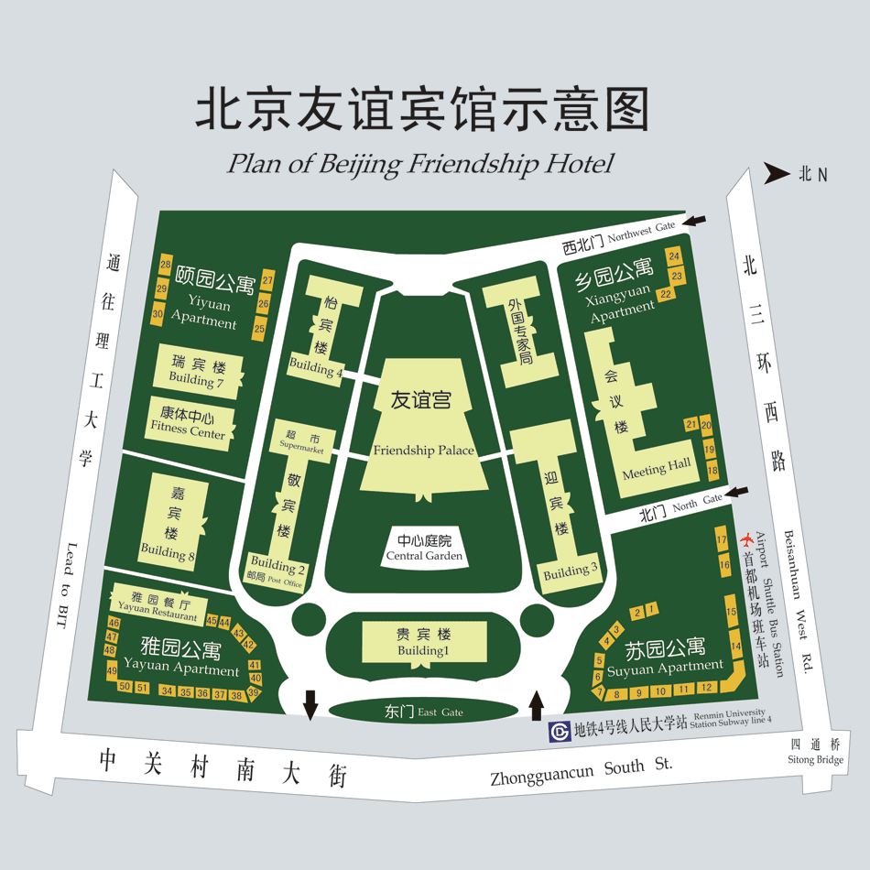
B
A
D
C
A: Building 1 | B: Building 4 | C: Building 8 | D: Friendship Palace

